ACR External Quality Control Program

Directions for performing test:
- Select the appropriate sample as indicated by the label on the vial
- Reconstitute by adding all of the supplied diluent
- Allow to stand for 5 minutes
- Swirl the contents until homogenous
- Run the sample as a Quality Control test with the QC ID being the sample number indicated on the bottle
- Pour some of the sample into the lid of the vial and fill the test cartridge capillary completely by holding the sampling device almost horizontal and bringing the capillary tip into contact with the surface of the sample. Do not wipe the capillary. Avoid air bubbles or excess sample on the outside of the capillary.
- Once analysis is complete, fill out this sheet and fax results to the iCCnet SA office (08) 7117 0635

SAMPLE NUMBER

ACR Result (mg/mmol)

Albumin Result (mg/L)

Creatinine Result (mmol/L)

Date/Time Reconstituted

Date/Time Analysed

Operator

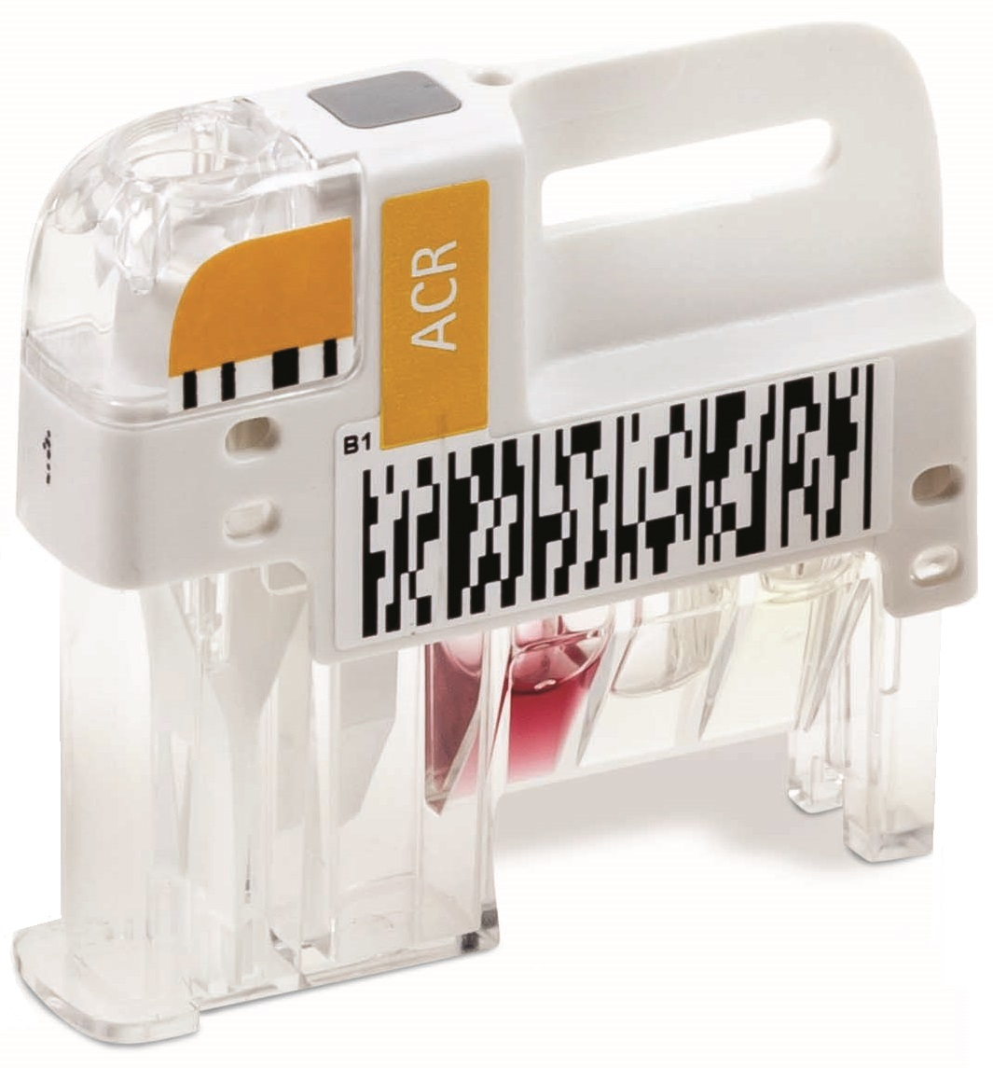
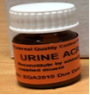

Site Name

Please Return results to iCCnet SA on 08 7117 0635

