CRP External Quality Control Program

Directions for performing test:
- Select the appropriate sample as indicated by the label on the vial
- Carefully add exactly 0.5 mL of distilled water (or water for injection) and allow the contents to dissolve for 15 minutes.
- Swirl the contents until homogenous
- Run the sample as a Patient test with the QC ID being the sample number indicated on the bottle
- Pour some of the sample into the lid of the vial and fill the test cartridge capillary completely by holding the sampling device almost horizontal and bringing the capillary tip into contact with the surface of the sample. Do not wipe the capillary. Avoid air bubbles or excess sample on the outside of the capillary.
- Once analysis is complete, fill out this sheet and fax results to the iCCnet SA office (08) 7117 0635

SAMPLE NUMBER

CRP Result (mg/L)

Date/Time Reconstituted

Date/Time Analysed

Operator

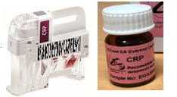
Site Name

Please fax results to iCCnet SA on 08 7117 0635

