Lipids External Quality Control Program

Directions for performing test:
- Select the appropriate sample as indicated by the label on the vial
- Carefully add exactly 0.5 mL of distilled water (or water for injection) and allow the contents to dissolve for 15 minutes.
- Swirl the contents until homogenous
- Run the sample as a Patient test with the patient ID being the sample number indicated in the bottle
- Draw the solution into the plastic pipette and apply a drop of control solution on to the disc’s suction point, ensuring the sample area is completely filled.

- Press the hinge cover down firmly until two clicks are heard and place the disc into the machine.
- Once analysis is complete, fill out this sheet and fax results to the iCCnet SA office (08) 7117 0635

SAMPLE NUMBER

Total Cholesterol (mmol/L)
LDL Result (mmol/L)
HDL Result (mmol/L)
Triglycerides Result (mmol/L)
Date/Time Reconstituted
Date/Time Analysed
Operator

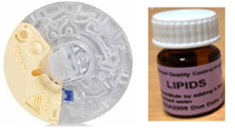

Site Name

Please fax results to iCCnet SA on 08 7117 0635

