INR External Quality Control Program

Directions for performing test:
- Select sample number, as indicated by the label on the bottle
- Open the bottle of control very carefully, avoiding loss of any lyophilised material
- Using scissors, cut off the tip of the dropper (long skinny part) and carefully add all the red diluent to the bottle
- Gently swirl the bottle 2 to 3 times to dissolve the powder, avoiding foam formation
- Once dissolved, select patient test and scan the barcode on the vial (XS Pro/Pro II) or manually type in “EQA” and the cycle number indicated on the bottle
- Insert the test strip into the machine when prompted
- Draw the solution into the larger dropper by gently squeezing the bulb and releasing it whilst in the solution. Apply a couple of drops to the test strip when prompted by the instrument
- Test the control solution on your instruments. The solution is stable for 10 minutes
- Once analysis is complete, fill out this sheet and fax results to the iCCnet SA office (08) 7117 0635 and please download results to iPOCCS via the dock (electronic download for SA Health Hospitals)
- Discard the bottle of control

EQA NUMBER

 | Serial # | INR Result
Instrument 1
Instrument 2
Instrument 3
Instrument 4

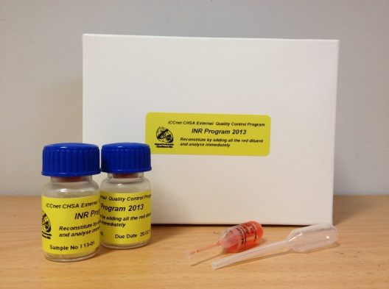
Date/Time Analysed

Operator

Site Name

Please fax results to iCCnet SA on 08 7117 0635
INR External Quality Control Program

