Troponin/ NT-proBNP External Quality Control Program

Directions for performing test:
- Select sample by the label on the bottle
- Open the bottle of control very carefully, avoiding loss of any lyophilised material
- Carefully add exactly 0.5 mL of distilled water (or water for injection). Close the bottle carefully and allow the contents to dissolve for 5 minutes by occasionally swirling the contents whilst avoiding foam formation.
- The control solution is now ready to run on the cobas h 232 machine. Ensure that the solution is not kept at room temperature for >10 minutes as the Troponin T concentration will drop, causing false results
- Select patient test and scan the barcode on the vial
- The control solution is now run the same way as a patient test (i.e. add 0.15mL of solution to the test strip)
- Once analysis is complete, fill out appropriate sheet (including test strip lot number) and fax results to iCCnet SA office (08) 7117 0635 and please download results to iPOCCS via the dock (electronic download for SA Health Hospitals)
- Discard the bottle of control

EQA Number

Test Strip Lot Number Result

ng/L

Troponin T

pg/mL

NT-proBNP*

*Please note: NT-proBNP testing is only required by sites that keep these strips in stock and it is to be performed after testing Troponin T

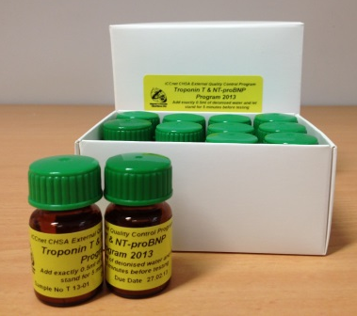

Date/Time Analysed

Operator

Site Name

Please fax results to iCCnet SA on 08 7117 0635

